Course Project – Turning Data into Business Opportunities

Shaun Pritchard

Rasmussen College

QMB4100

Darice Corey

May 05, 2021

**Course Project – Turning Data into Business Opportunities**

**Business opportunity**

The business opportunity that I have identified related to the topic of meal planning with all recipes. Is a business opportunity based on the digital service product of meal planning? Currently, there is no social network or application was social network capabilities that facilitate not only sharing recipes but the opportunity to build meal plans from those recipes and to share those recipes amongst The Social Network and user's followers. This would be a unique opportunity for allrecipes.com. The scope of the idea is to create a new user experience that provides users access to creating a meal plan from trending recipes, social creators, influencers, and having the ability to implement meal plans share them, and engage on a new level with the recipes provided on the platform.

**Data Needed**

I would need to look at comparative data that outlined the competitive advantage of this business opportunity. Data that shows trends on meal planning and usage of utilities based on the concept and the recipes, ingredients, and user base composition. I would also need to facilitate data that would exclusively show the feasibility of the new digital in-app service through supporting information to show how meal planning would be beneficial to the user base. Also, testing and survey data from existing platform users could facilitate sound datasets and feedback for this proof-of-concept.

**Resource and data repositories needed**

The resources and data repositories I would need to use for proof of concept would be current in-app user social data from the allrecipes.com platform. I would need data that shows recipe trends and rankings to be correlated with meal planning diet categories. I would need raw search and static search engine data to show comparatives in trends and prove if the competitive advantage of this business opportunity is viable based on keyword, popularity, engagement, behaviors, and trends.

The data that we need to be acquired for this business opportunity to become a feasible reality would be search engine analytics data, search engine Trends data, meal planning data from API. Ingredients data from API's, recipe nutrition facts and data, unstructured user data from the Allrecipes.com platform, global and nutrition data for the comparative and predictive analysis in specific recipes to allocate recipe categories into specific meal plans.

These data repositories would initially have to be open source or from viable data acquisition companies. Currently, allrecipes.com uses a data acquisition company called Esha research.

* ESHA implements a suite of nutritional software products, services, and databases that are recognized as the industry’s top choice for food and supplement formulation, recipe development, labeling, nutritional analysis, and regulatory compliance.
* Standard USDA national agricultural Library US Department of culture data on food composition. Such as nutrient list USD foodservice and research nutrient content US food supply, diet, and Health Data.
* I would also need global data that would facilitate food composition nutrient data content global food supply, diet, and Health Data.

**Change and Processes**

Initially implement systems to improve data collection first and foremost followed by a structured pipeline system to Aggregate and table the data for real-time use. The data collection business process would be outlined to follow these methods.

**Improve the data allocation process:**

* Think about what customer interactions are important
* Think about what behavior-related data is important
* Identify the data sources you are going to use
* Set a reasonable frequency for collection and analysis
* Keep in mind who will be viewing the reports

Often the most important data you need is concerning the users of the platform. Defining important customer interactions should be one of the first steps. Planning to measure specific metrics of data to define success and failure of marketing plans, sales initiatives, and tracking Trends do predictive analysis. Also, to incorporate processes to eliminate redundancies and look like the data unlimited different systems from which the reports and data will be transformed extracted when implementing data collection systems and subsequent data analysis systems.

Finally, I would need to incorporate a data pipeline. A data pipeline is a series of data processing steps. If the data is not currently loaded into the data platform, then it is ingested at the beginning of the pipeline. Then there are a series of steps in which each step delivers an output that is the input to the next step. This continues until the pipeline is complete. In some cases, independent steps may be run in parallel. I need to implement a data pipeline as opposed to ETL to handle different streams of data and the rates and types of processing that need to happen to facilitate the result.

**Trends to identify using this data**

Many trends could be Identified from the acquisition of this data and its process. Here is a list and description of several trends that I feel would be very important to the implementation of this project. These trends need to be implemented using Predictive, comparative, and descriptive Analytics.

* Diet trends
* Recipe trends per diet category
* User engagement of shared meal plans
* Most popular meal plans
* Marketing trends and in-app purchases from use of meal plan
* Comparative trends of other meal planner applications
* User behaviors and trends

**Data visualization**

In this implementation, we need to show visualizations of how unique this business opportunity is and how viable the potential for this business opportunity could be. The data visualization below shows how opportune this implementation could be through several factors. First, we can see using search engine analytics from Google of Allrecipes.com compared to the top Meal planning apps keywords.

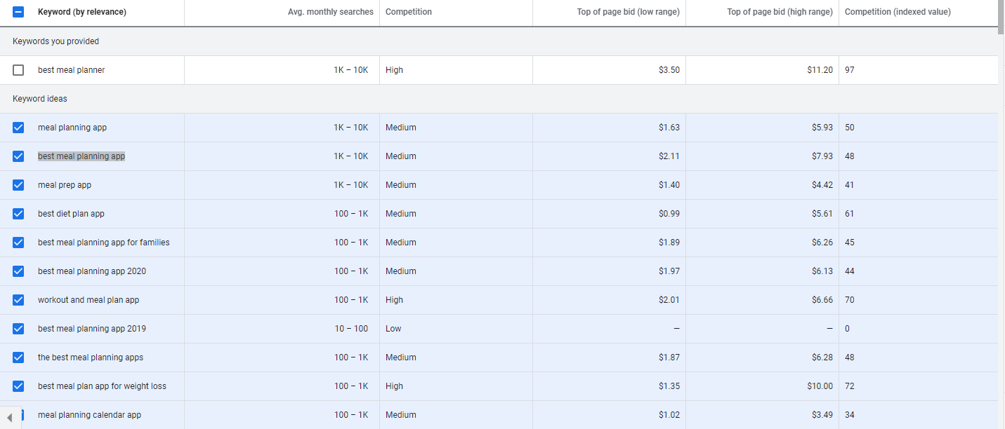

Comparison trends of between Allrecipes.com, Mealime.com, and Emeals.com which are rated as the top Apple store and Google play store meal planning applications. We can see that All recipes.com has a major user advantage in the searches over the last year in 2020-2021 (Google Trends, 2021).

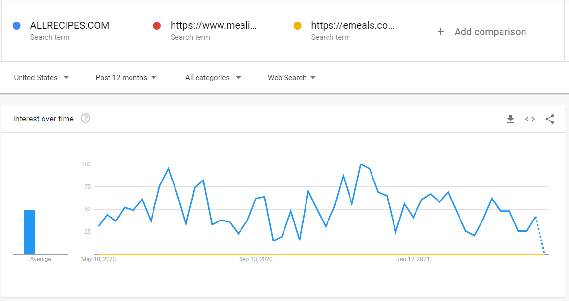

Here is data based on the intake for American adults over the age of 20 (CDC, 2021).

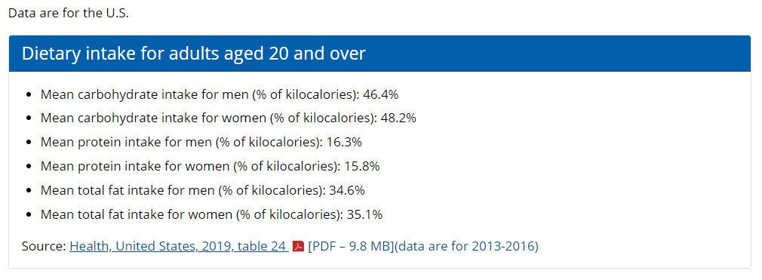

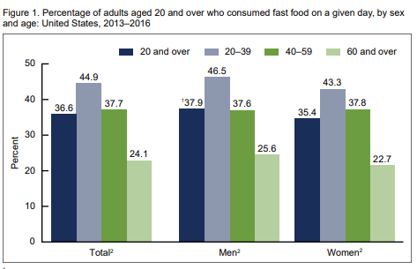

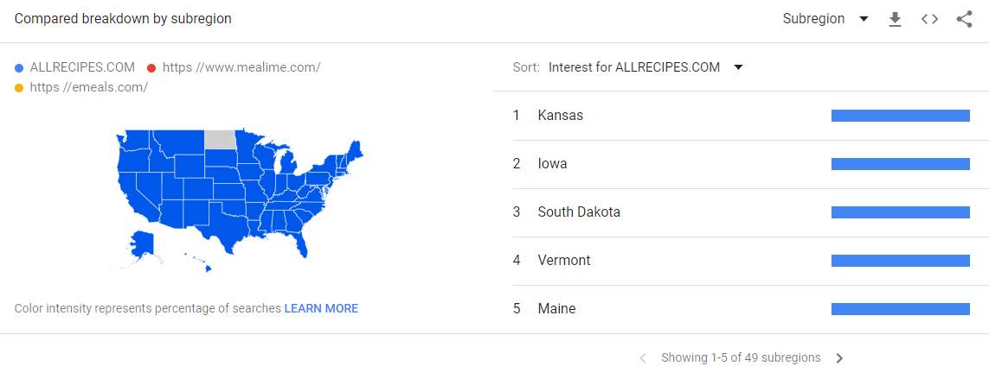

# References

CDC. (2021). *Fast Food Consumption Among Adults in the*. Retrieved from https://www.cdc.gov: https://www.cdc.gov/nchs/data/databriefs/db322-h.pdf

Google Trends. (2021). *Google Trends*. Retrieved from https://trends.google.com: https://trends.google.com/trends/explore?geo=US&q=ALLRECIPES.COM,https:%2F%2Fwww.mealime.com%2F,https:%2F%2Femeals.com%2F